|  |  |  |
| --- | --- | --- |
|  |  | INSTITUTO INTERNACIONAL DE IDIOMAS  ENGLISH III – Task 1  *“My City Used To…”* |

**Name & Code: CARLOS DAVID ESCAMILLA**

**CODE: 202311162**

**Task links:** <https://youtu.be/A0HE3kCdE2A>

<https://www.canva.com/design/DAGhvm2nA-g/kr7D-p-qR0-u2poKNXU1yw/edit?utm_content=DAGhvm2nA-g&utm_campaign=designshare&utm_medium=link2&utm_source=sharebutton>

**Student’s ID CARD (PHOTO):**

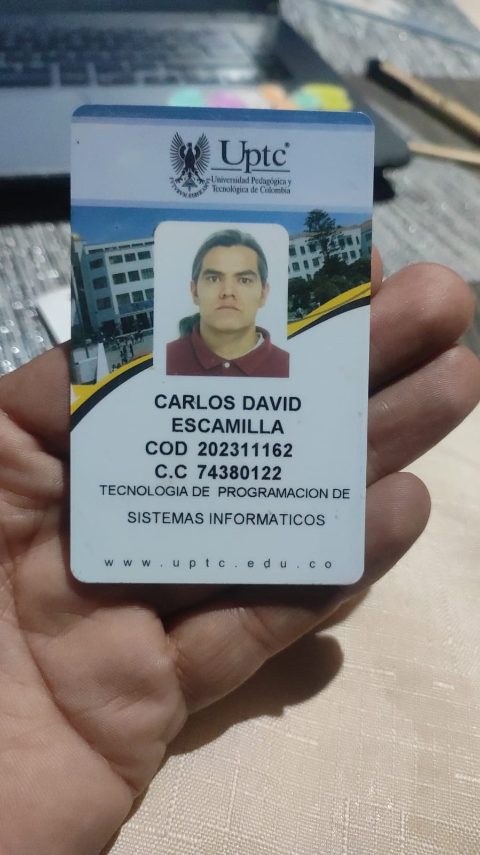

**Context:**

1. The transportation 10 years ago.

* Transportation in my city was so messy, ten years ago
* The buses ran from Monday to Saturday.
* Several traffic lights did not work for weeks

1. Family members who lived in your city.

* Most of my family was never live here.
* My elder brother lived here for a while.
* I did not live in this city 13 years ago.

1. Fast food restaurants where you lived.

* Fast food restaurants were everywhere, just like nowadays
* I used to eat fast food sometimes
* I didn't like too much fast food.

1. Turistical places around you live.

* Near my house there was a historic and touristic park
* I visited most of touristic places in this city
* Most people did not know about some touristic places in this city.

1. Security in your city.

* In my city, some areas always were safer than others
* One night, two men assaulted and robbed me.
* People did not feel safe in the nights.

1. Old places that don’t exist anymore in your city.

* There was a lake in the park 5 years ago.
* A friend talked me about a monument to Indians, that don’t exist anymore.
* Government did not make enough efforts to preserve historic places.

1. Stores / mall that opened recently where you live.

* The old cinema was at the new mall location.
* Recently, I went to cinema at the new mall.
* The old mall did not have elevator, but the new does it.

1. Friends that you studied with.

* My two best friends were my partners at school.
* Last week, died a school partner.
* Most of my school partners did not marry yet